Code Coverage Test on Local System

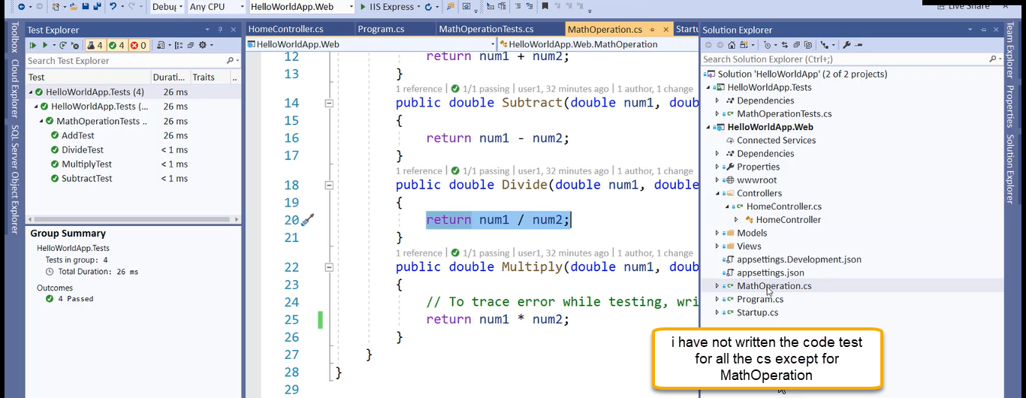

Coverlet will generate some of report for us

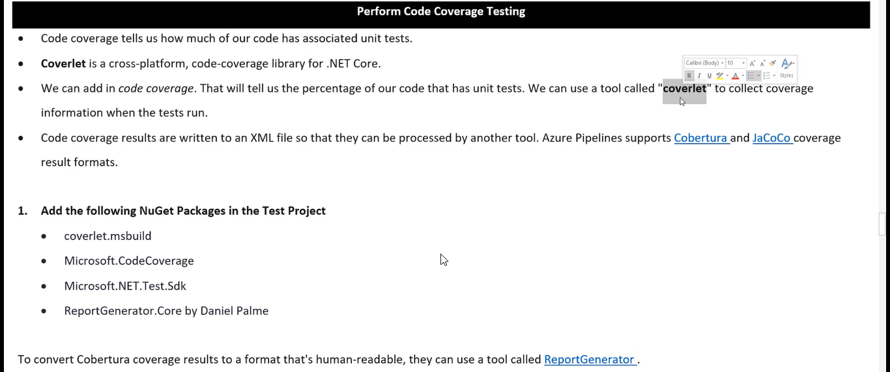

The generated report will be in the from of xml and now we need to convert into html for .dot net we will use Cobertura and for Java based application we will use the JaCoCo ( Java code coverage)

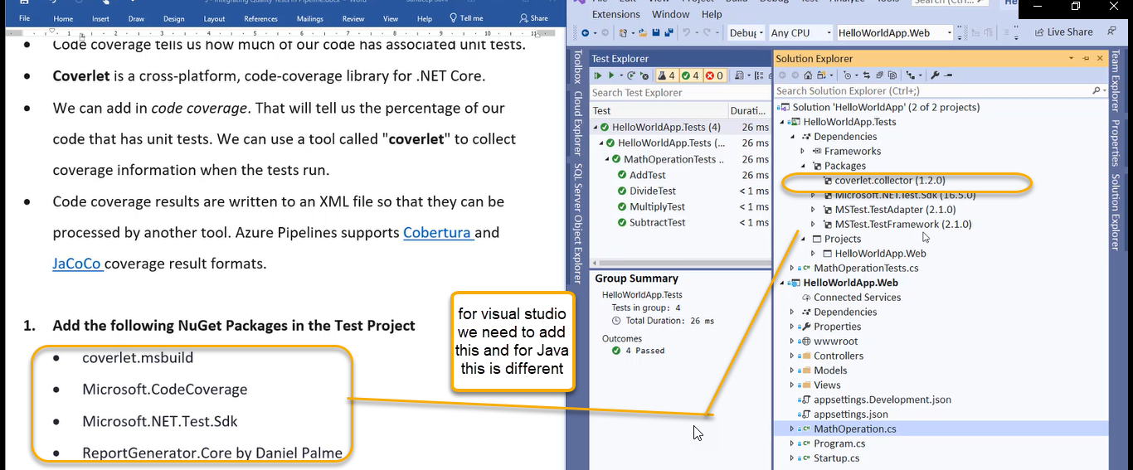

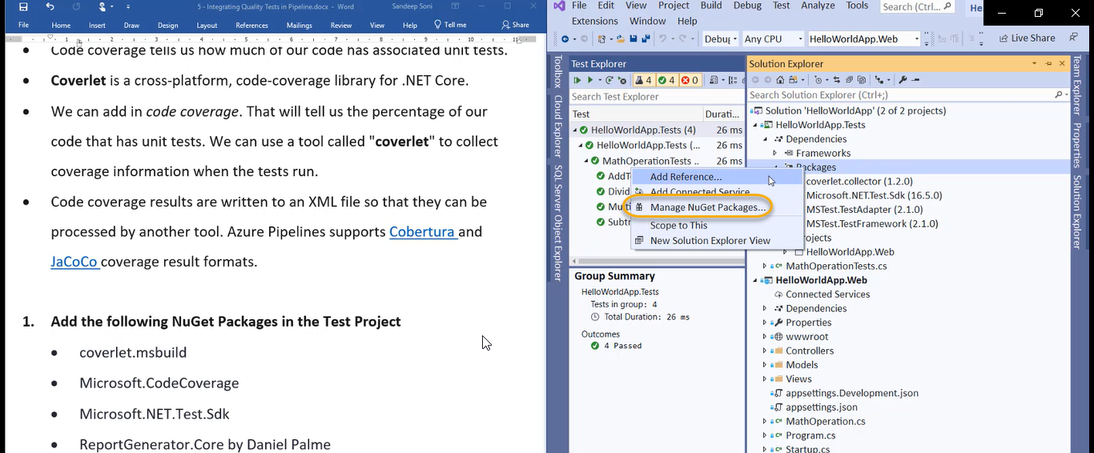

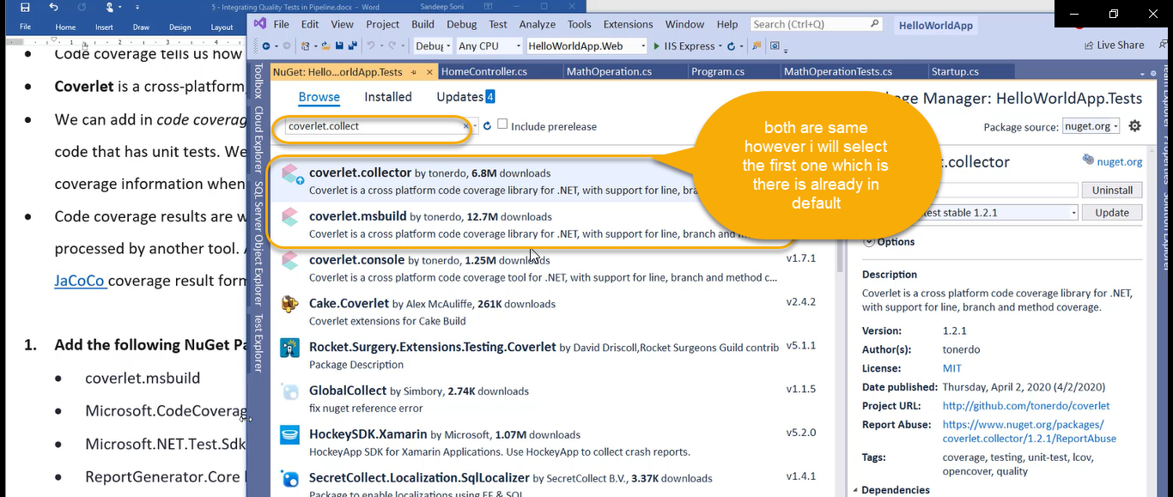

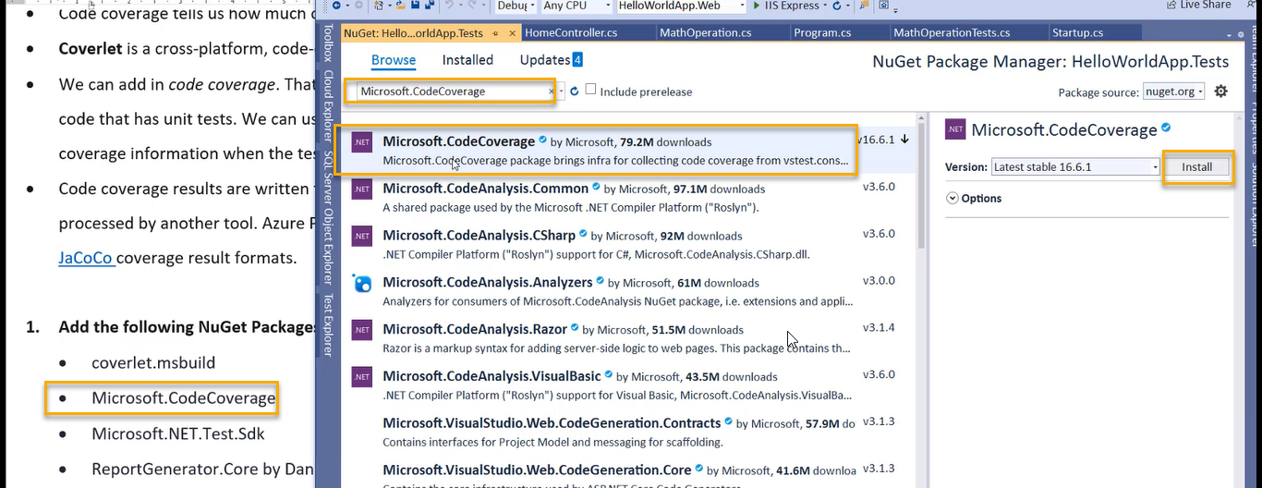

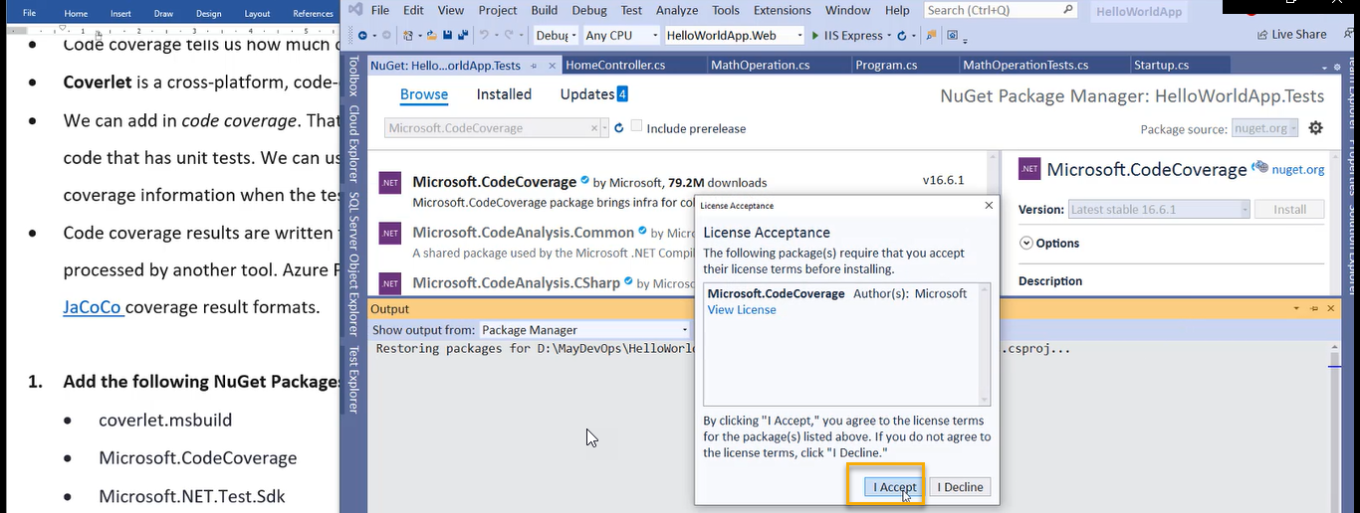

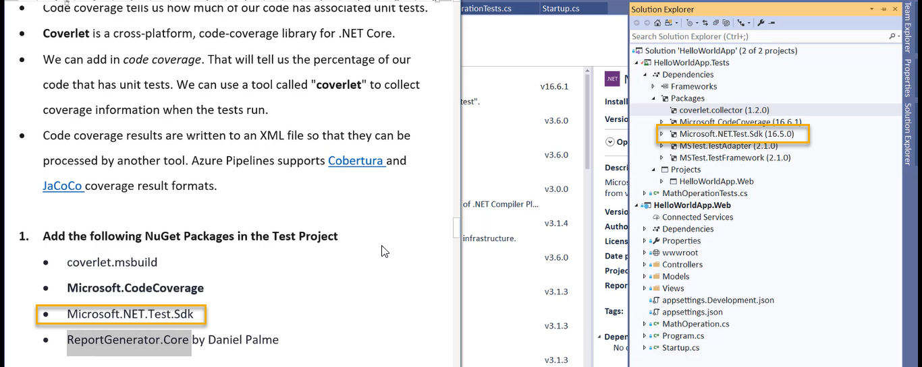

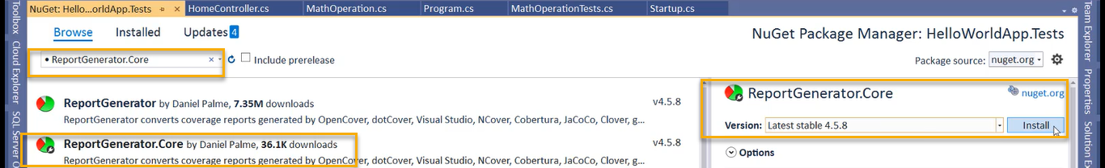

All the nuget projects are added now

Now install a tool which is used by dot net for generating the report

Execute the below one in CMD



We need to do same things in pipeline that means on the agent machine host agent I need to install the global tool

If it is Microsoft agent, we will definitely keep in pipeline for every build and if it is self-hosted agent, we can directly execute this step on that machine one time because in Microsoft hosted agent the build is destroyed after every run

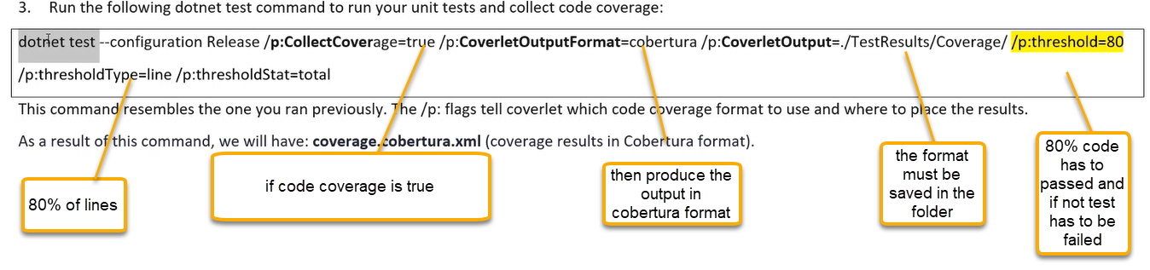

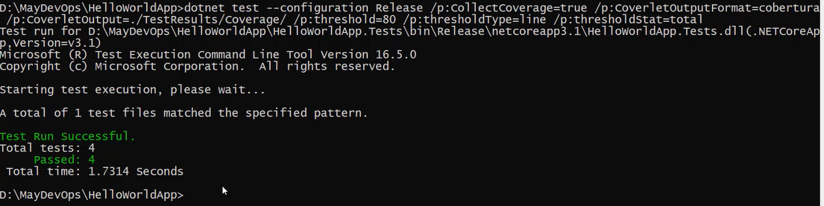

However the report is NOT generated

The issue is with we have installed the wrong nuget for first one

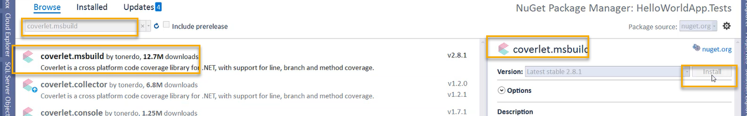

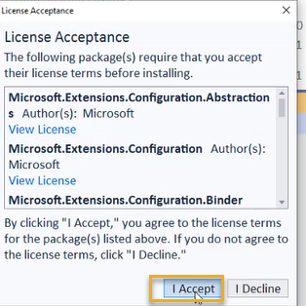

And now run again in cmd

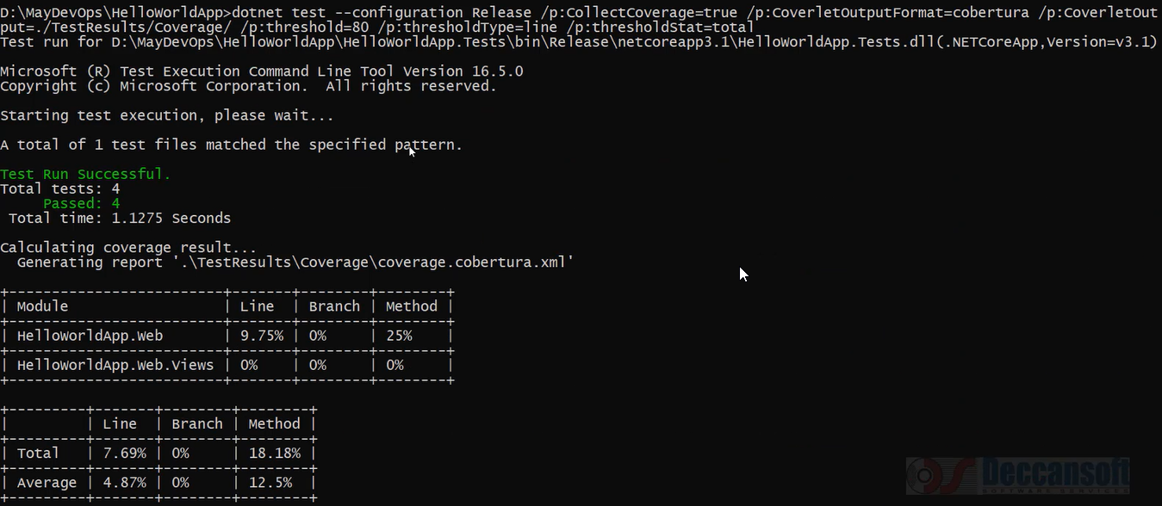

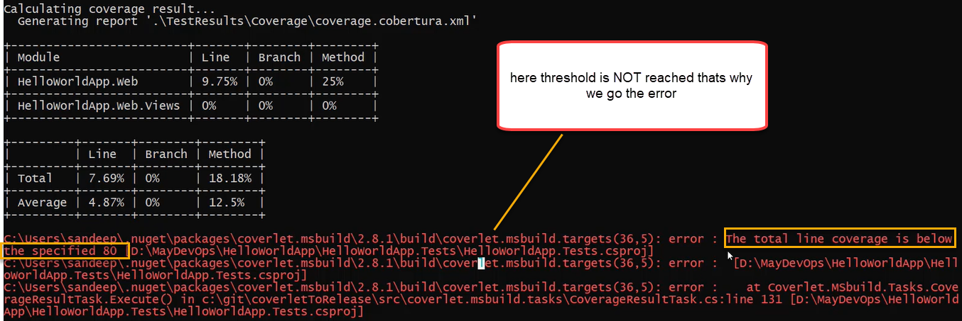

And now if you change the threshold to 7 it will pass

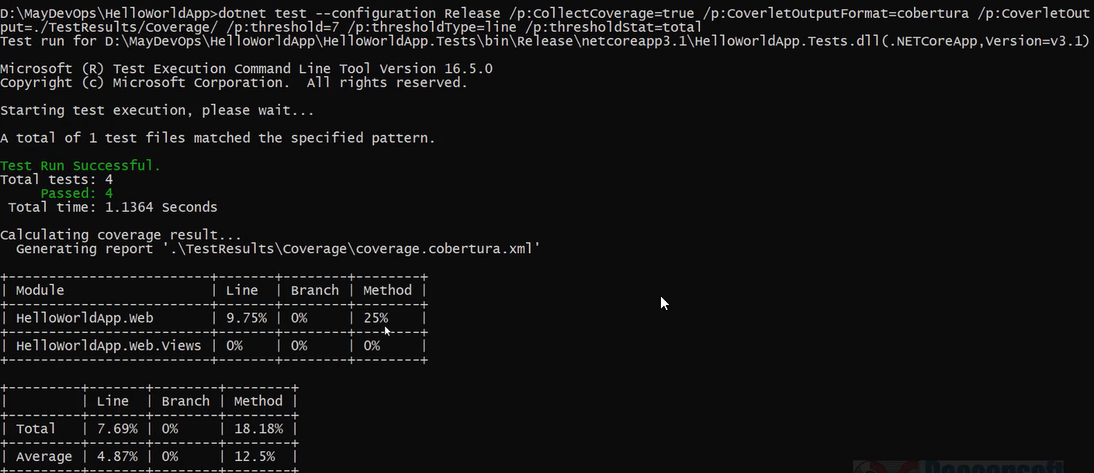

And we the same in locally

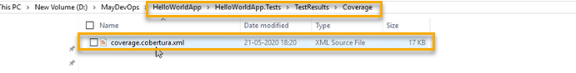

From this xml we need to generate the html

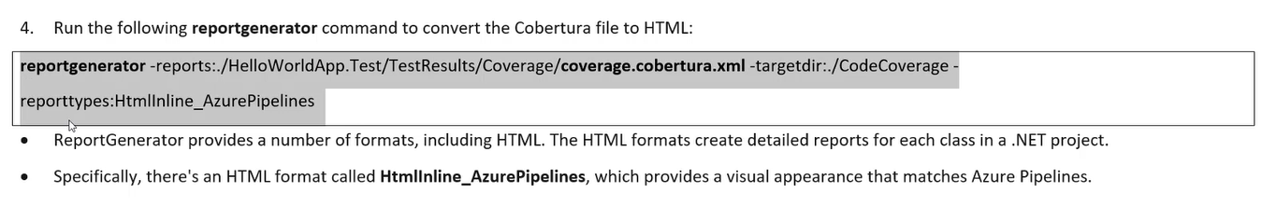

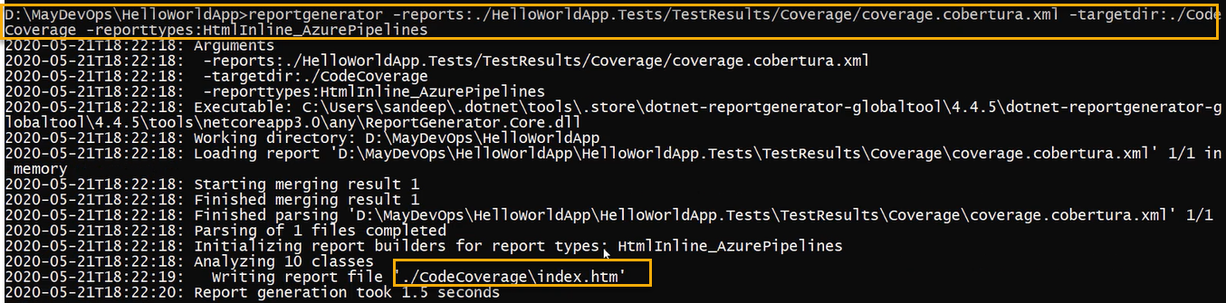

And we see the same in locally

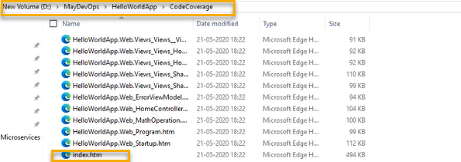

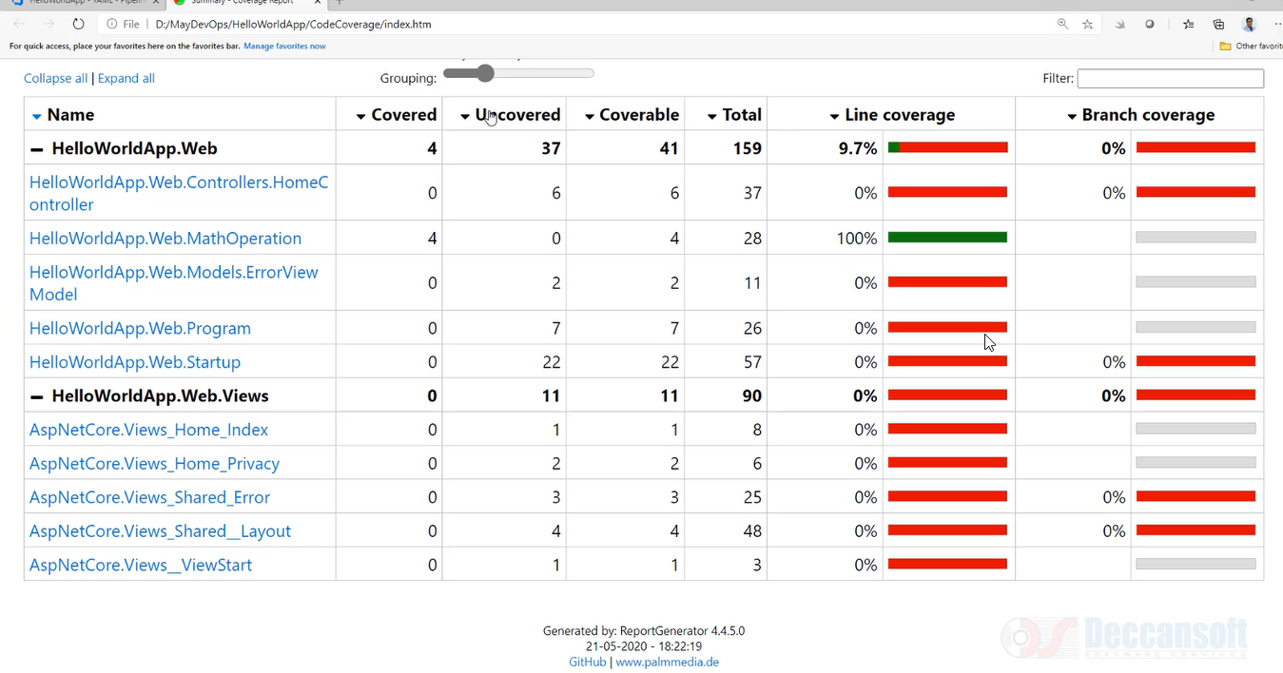

Integrating Code Coverage Test in CI Pipeline

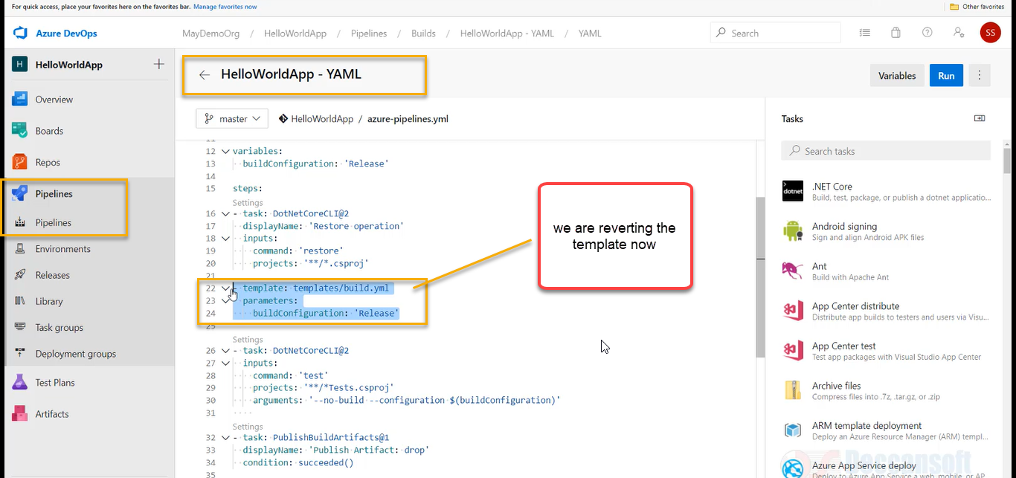

I don’t want to build and publish unless the code coverage is properly done

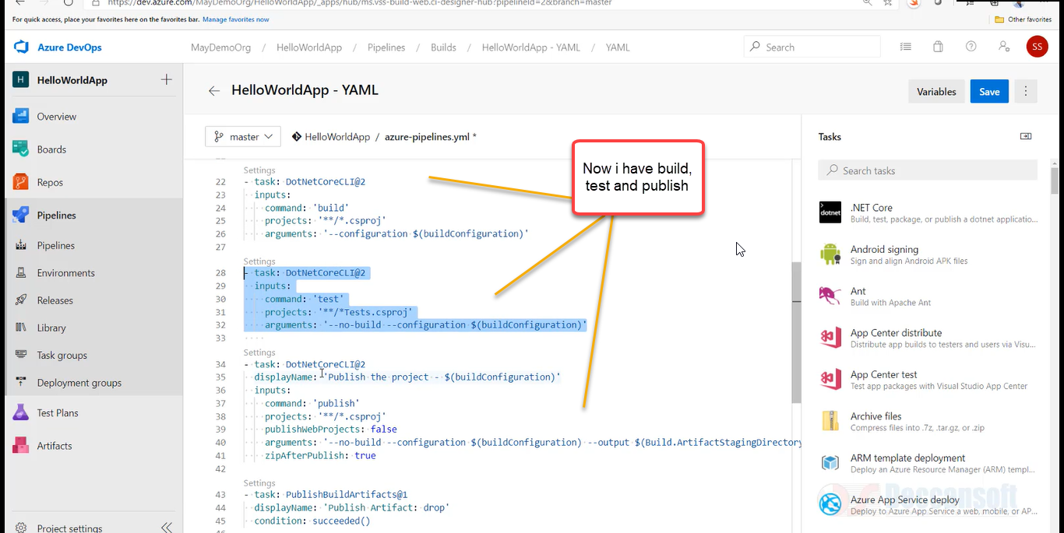

Copy the below one

- task: DotNetCoreCLI@2

displayName: 'Install ReportGenerator'

inputs:

command: custom

custom: tool

arguments: 'install --global dotnet-reportgenerator-globaltool'

- task: DotNetCoreCLI@2

displayName: 'Run unit tests - $(buildConfiguration)'

inputs:

command: 'test'

arguments: '--no-build --

configuration $(buildConfiguration) /p:CollectCoverage=true /p:CoverletOutputFormat=cobertura /p:Coverlet

Output=$(Build.SourcesDirectory)/TestResults/Coverage/'

publishTestResults: true

projects: '**/*Tests.csproj'

- script: |

reportgenerator -reports:$(Build.SourcesDirectory)/**/coverage.cobertura.xml -

targetdir:$(Build.SourcesDirectory)/CodeCoverage -reporttypes:HtmlInline_AzurePipelines

displayName: 'Create code coverage report' - task: PublishCodeCoverageResults@1

displayName: 'Publish code coverage report'

inputs:

codeCoverageTool: 'cobertura'

summaryFileLocation: '$(Build.SourcesDirectory)/**/coverage.cobertura.xml'

and paste in under the test

and click on save and again click on save

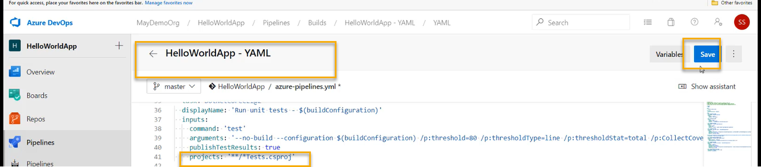

and click on save and again click on save

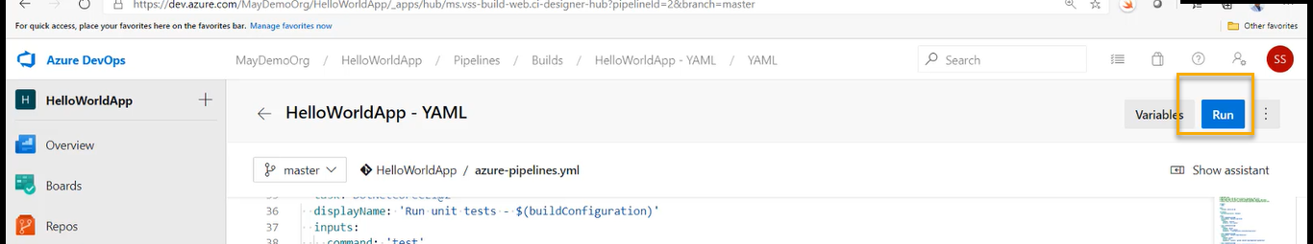

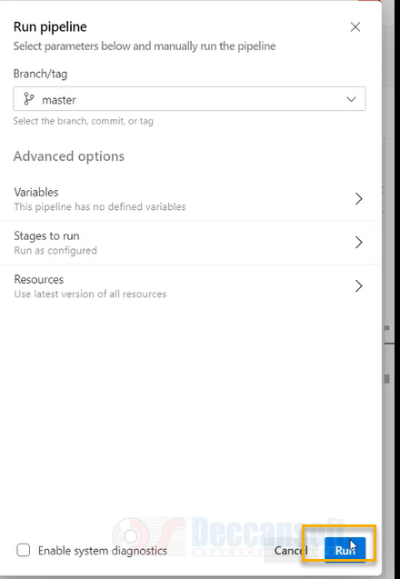

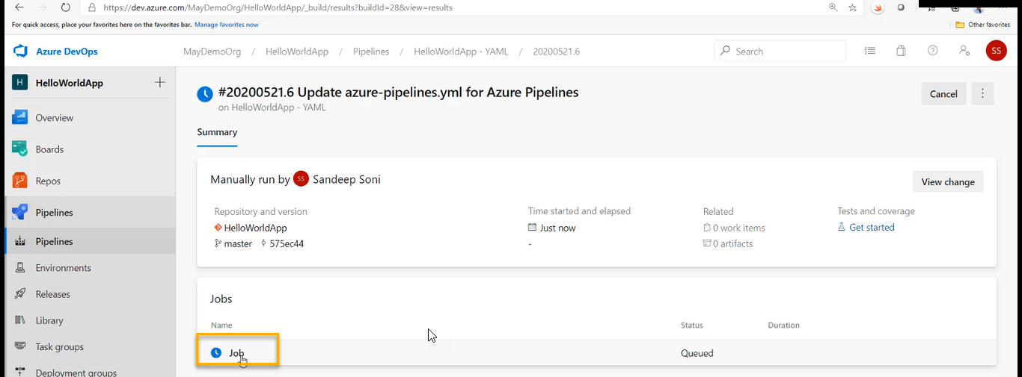

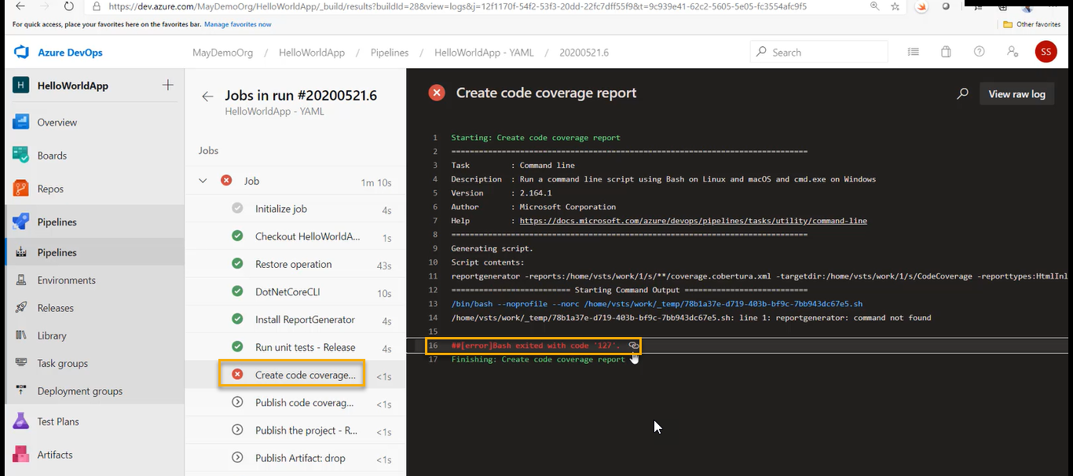

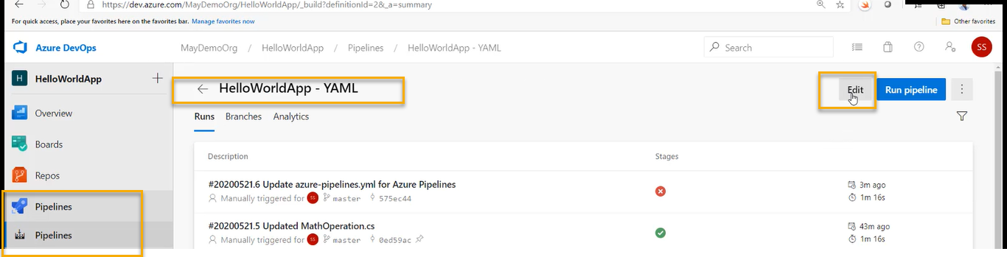

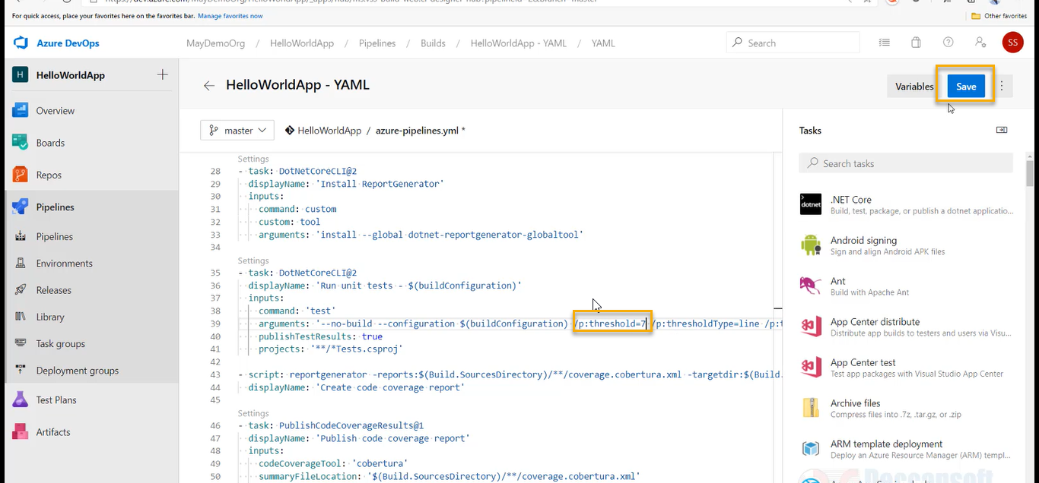

And gain save it

And again Run it > Run it



As shown above we will got again error

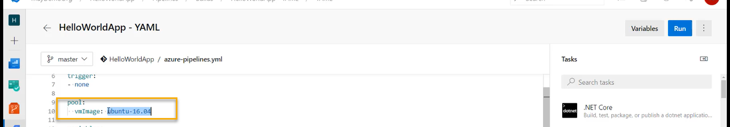

Change to windows

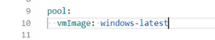

Because the format of this command is windows

And again save it > save it

And again Run it > Run it

Again we got the error

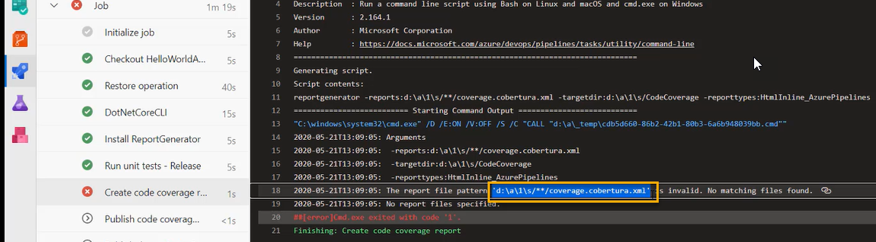

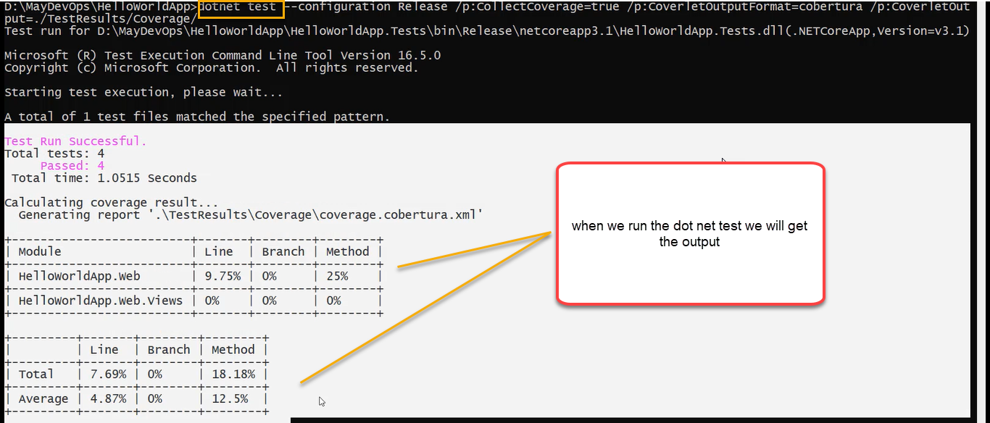

However, in pipeline it is not generated

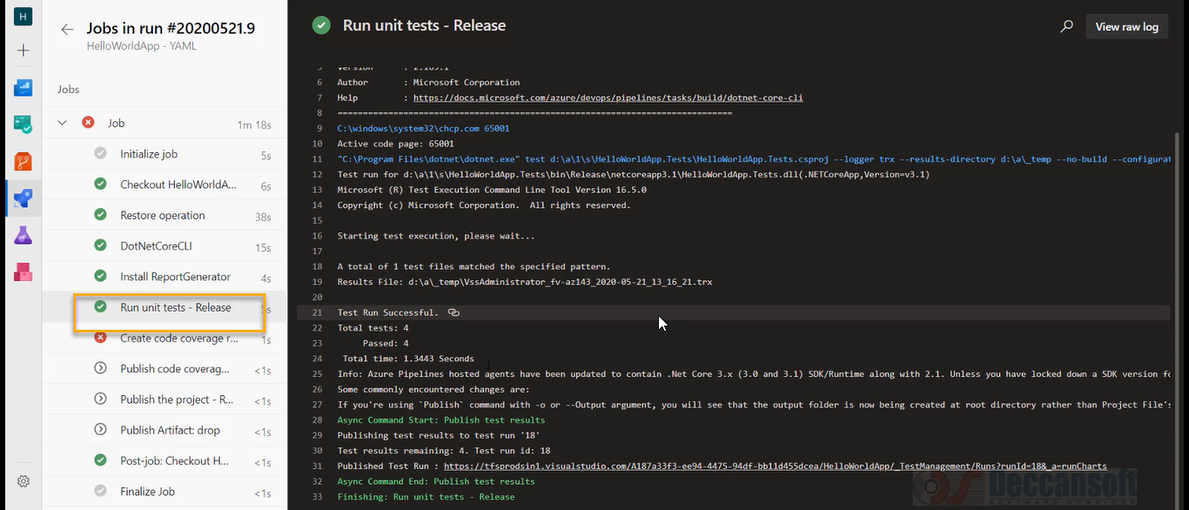

So error is in unit test NOT in code coverage

After adding the nugget packages in locally we need to push to master

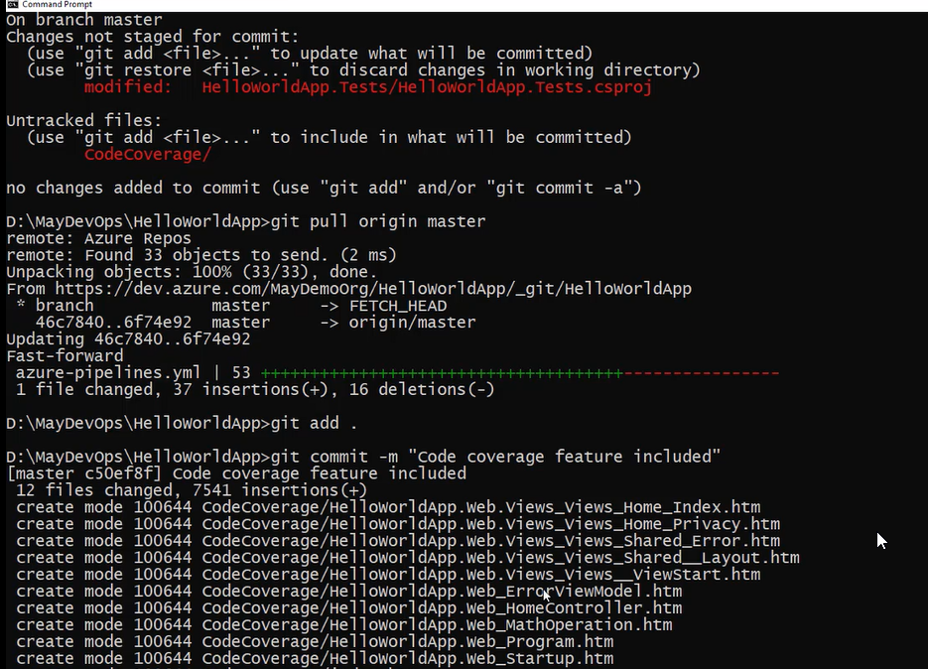

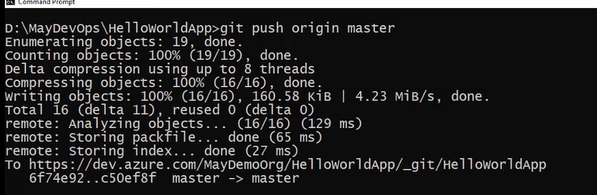

Now run again

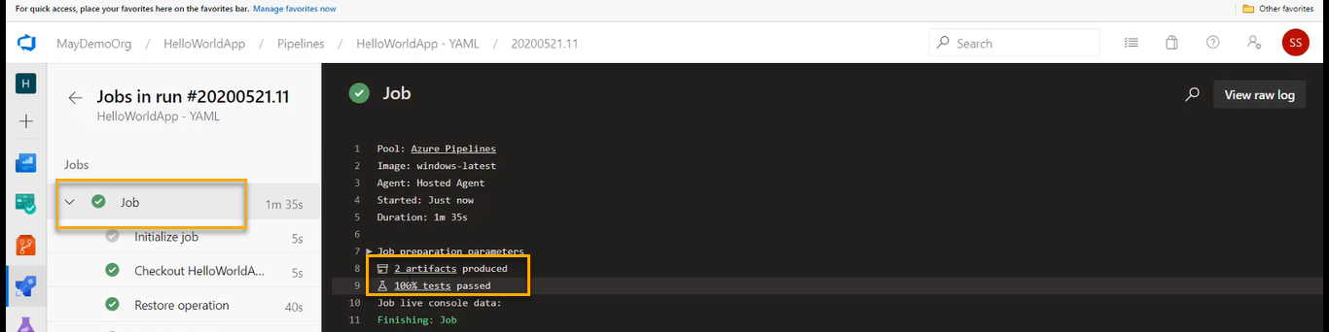

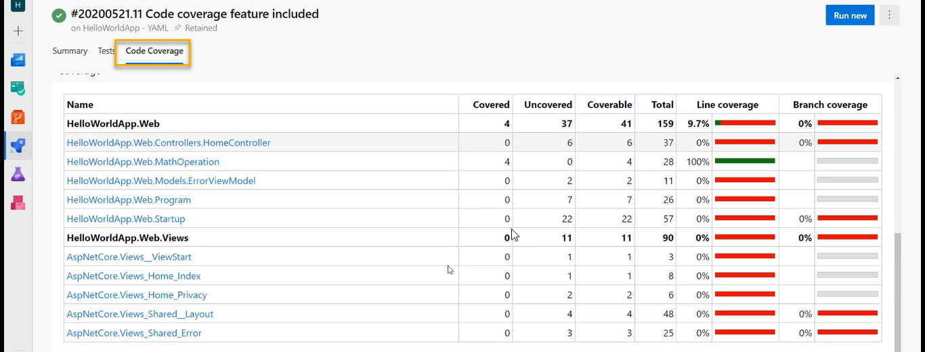

What ever output we see in locally we see the same in Azure devops